EXPERIMENT:5(B)
MODELLING AND SIMULATION OF 4-LAYER IOE ARCHITECTURE USING NODE-RED, MQTT AND A CLOUD DASHBOARD

Objective :
To model and simulate the four-layer IoE architecture (Perception, Network, Middleware, and Application) using Node-RED and MQTT, and visualize real-time sensor data on a dashboard.

Procedure :
- Install and configure Node.js, Node-RED, and the Mosquitto MQTT broker.
- Perception Layer: Simulate sensor readings such as temperature and humidity.
- Network Layer: Transmit sensor data using the MQTT protocol.
- Middleware Layer: Use Node-RED to receive, process, and organize the sensor data.
- Application Layer: Display the processed data on a dashboard using gauges, charts, and status indicators.
- Deploy the Node-RED flow and verify real-time data transmission across all four layers.

Output

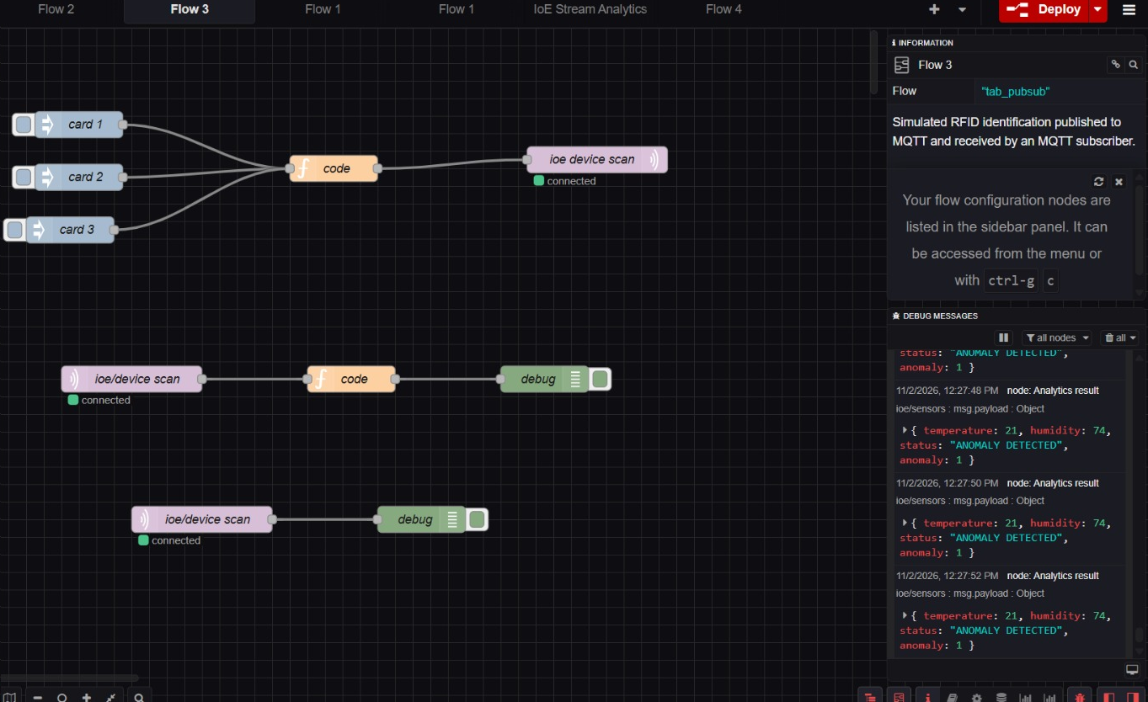

Result :
The four-layer IoE architecture was successfully simulated using Node-RED and MQTT, enabling sensor data transmission, processing, and real-time visualization on the dashboard.

